

**EVALUATION OF INTERNSHIP REPORT**

## B.Tech : III Year

**Department of Computer Science & Information Technology**

**Name of the Student: ISHIKA SHROFF**

**Branch & section: CSIT 2**

**Roll No: 0827CI201080**

**Year: 2022**

## 

## 

## 

## Department of Computer Science & Information Technology

**ACROPOLIS INSTITUTE OF TECHNOLOGY & RESEARCH, INDORE**

**CERTIFICATE**

Certified that training work entitled “*NEWS BOT in UiPath studio*” is a bonafied work carried out in fifth semester by “*Ishika Shroff*” in partial fulfillment for the award of the degree of Bachelor of Technology in Computer Science and Information Technology from “*Prof. Simarjeet Singh Bhatia/Assistant professor CSIT department* “of Acropolis Institute of Technology and Research, during the academic year 2022-23.

*Prof. Simarjeet Singh Bhatia Prof. Nidhi Nigam*

**ACROPOLIS INSTITUTE OF TECHNOLOGY & RESEARCH, INDORE**

**ACKNOWLEDGEMENT**

I would like to acknowledge the contributions of the following people without whose help and guidance this report would not have been completed. I acknowledge the counsel and support of our training "*Prof. Simarjeet Singh Bhatia/Assistant professor CSIT department*”, CSIT Department, with respect and gratitude, whose expertise, guidance, support, encouragement, and enthusiasm has made this report possible. Their feedback vastly improved the quality of this report and provided an enthralling experience. I am indeed proud and fortunate to be supported by him. I am also thankful to Dr. Shilpa Bhalerao, H.O.D of Computer Science Information Technology Department, for her constant encouragement, valuable suggestions and moral support and blessings. Although it is not possible to name individually, I shall ever remain indebted to the faculty members of CSIT Department, for their persistent support and cooperation extended during this work.

***ISHIKA SHROFF***

***0827CI201080***

### INDEX

S.no CONTENTS

1. Introduction to technology Undertaken

2. Objectives

3. Project undertaken

4. Screenshots of Project

5. Conclusion

6. References

## What is UiPath?

UI path is one of the widely used robotic process automation tools and it was founded in the year 2015 to provide software that can eliminate the tedious time consuming back office works. It converts boring tasks into automated ones with the help of unique tools. It enables your processes to be more effective and reliable.

### Products of UiPath

We have three products available on the UIPath platform. They are as follows.

**UIPath Studio:**

A successful automation business requires a tool that can have the capability to model your business process despite the complexities and the scale of activities that your company is associated with. [UIPath Studio](https://www.uipath.com/product/studio) is a powerful, user-friendly automation canvas available on UIPath.

* UIPath Studio has a wide variety of features that can easily integrate with any language and promotes ease of use, efficiency, and scalability. UIPath Studio enables us in designing our automation process in a visualized way.

**UIPath Robot:**

The Job of a UIPath Robot is to start the executing process, once you get completed with the  UIPath Studio process. The Robot will begin executing business activities with perfect accuracy. All a robot needs is a perfectly predefined rule and set of accurate data.

**UIPath Orchestrator:**

 It is a server-based application that helps us in managing the automation process such as deploy, schedule, monitor, and manage robots processes. It acts as a central platform in managing the overall performance of the automation.

* The Orchestrator runs on a server to connect all robots to this server and passes instructions on different events such as whether to attend, unattended, or be idle for a particular event. Browser-based orchestration enables the management of hundreds of robots through a single click.

### Types of UI Path projects

There are two types of standalone projects that are available in the UIPath and they are process and library. Let's discuss each of them in detail.

**#1. Process**

A process forms an association between an environment and a package. A package is a predefined pack of services developed using the Jacada Integration and Automation (JIA) application.  Every time a package is inserted into an environment, it automatically gets distributed to all the robot machines that are connected to the environment.

The process page will allow you to manage previously created associations, deploy an uploaded package to the robot environment, and keeps all your processes up to date. It facilitates us in easily distributing the packages on the robot machines and creates a faster process from the jobs page.

**#2. Library**

A library is a package that contains various reusable components. Libraries are saved in the form of files and can be installed when they are required to handle the excess workflows using the package manager. In Orchester, this is termed as a centralized place to store all the libraries, namely the library page. From this destination, the libraries are available to access by the people who have permission or accessibility to it.

A process library is defined as a sequence of tasks with a well-defined business function, which makes them suitable for reusability and sharing.  On the Libraries page, you have an option to view and delete the libraries that had been used on the UIPath Studio, and also the files that were uploaded manually. [Get 50% OFF](https://mindmajix.com/uipath-training?utm_source=blog&utm_medium=seo&utm_campaign=seo-promotion-aug-freedom-sale-2021)

### Types of Supported workflows in UIPath

In UIPath, Automation is associated with multiple aspects and it enables you to automate the rule-based process. To achieve effective automation, each work should be assigned to a specific thing and can be performed effectively. Each activity in UIPath has to undergo small activities like reading a file, clicking a button, writing a log panel, etc.

**Below mentioned are the essential workflows in UIPath.**

* **Sequences:**It best suits the linear process of moving from one stage to another without causing any disturbance to the workflow.
* **Flowcharts:**  It is designed to suit the organizations whose automation requires some logical ability. It clears all the problems in a diversified manner through multiple branching operations.
* **State machines:** It is well designed to suit the needs of organizations that have huge workflows and a large number of transactions. State machine uses an infinite number of states in their execution which is triggered by a condition (transition) or task.

### UiPath Features

1. **Application compatibility:**  It offers a facility to work with a wide range of applications, including web and desktop applications.
2. **Centralized repository:**This feature helps in handling all robots simultaneously by the users.
3. **Security measures:** It provides high-security auto-login features to run the bots.
4. **Advanced Screen Scraping solution:** Its scraping solution works with various types of applications such as Java, .Net, PDF, Flash, Legacy, and SAP with utmost accuracy.
5. **The best tool for Modeling the Business process:** The UIPath Studio provides automation excellence with its model business process.
6. **Scalability and Robustness:**  It is equipped with features like tackling debugging and exception handling mechanisms. Also, it looks after the activities of Artificial Intelligence like handling Outlook, Excel, PDF, etc.
7. **Application compatibility:**  It offers a facility to work with a wide range of applications, including web and desktop applications.
8. **Centralized repository:**This feature helps in handling all robots simultaneously by the users.
9. **Security measures:** It provides high-security auto-login features to run the bots.
10. **Advanced Screen Scraping solution:** Its scraping solution works with various types of applications such as Java, .Net, PDF, Flash, Legacy, and SAP with utmost accuracy.
11. **The best tool for Modeling the Business process:** The UIPath Studio provides automation excellence with its model business process.
12. **Scalability and Robustness:**  It is equipped with features like tackling debugging and exception handling mechanisms. Also, it looks after the activities of Artificial Intelligence like handling Outlook, Excel, PDF, etc.

**PROJECT UNDERTAKEN**

**The aim of this project is to demonstrate the use of data scraping from the web then automatically store scraped data into an excel sheet and then mail it to the intended user by the use of email automation in UiPath studio.**

# About Data Scraping

Data scraping enables you to extract structured data from your browser, application or document to a database, .csv file or even Excel spreadsheet.The scraping wizard can be opened from the **Design** tab, by clicking the **Data Scraping** button.

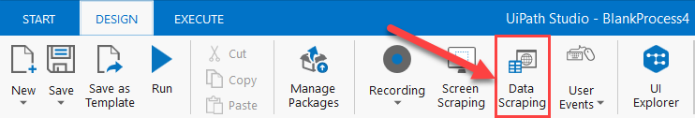

### ****About Email Automation****

The UiPath Email Automation course helps you learn how to automate working with emails and automation. Using UiPath Studio, you will be able to send emails using different activities, retrieve emails, filter emails, and more.

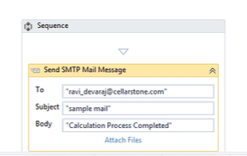

**PROJECT SCREENSHOTS**

**PROCESS**

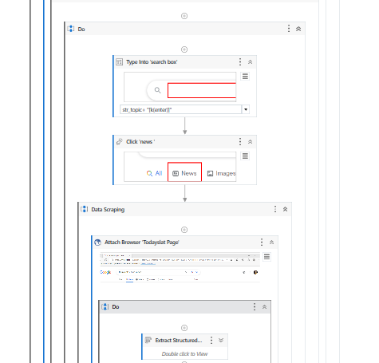

**EMAIL RECIEVED**

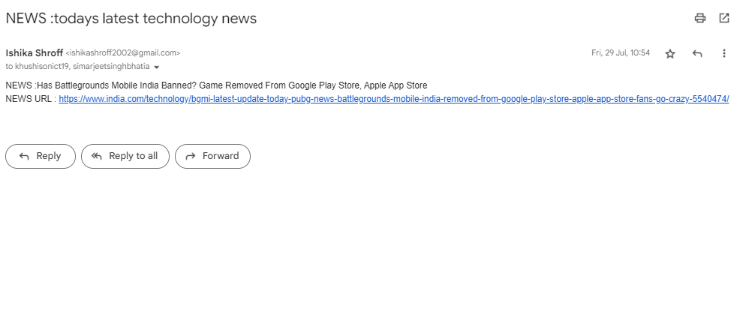

**CONCLUSION**

RPA has the ability to both minimize errors and improve efficiency, and, moving forward, will be critical for creating a seamless operational environment. Repetitive work will be accomplished more quickly and efficiently, so humans can be free to focus on more human-centric strengths such as reasoning, judgment, and emotional intelligence.

By implementing an RPA you may come up against some resistance and challenges. What will help your RPA on boarding is completing the groundwork upfront and emphasizing a clear vision to both your management team and personnel.

**REFERENCES**

https://capacity.com/rpa-and-workflows

https://academy.uipath.com/